**A Brief Documentation on Products UI/UX Improvement**

-By Amit KC

**What is UI/UX ?**

UI refers to the screens, buttons, toggles, icons, and other visual elements that a user interact with when using a website, app,etc.

UX refers to the entire interaction you have with a product, including how you feel about the interaction.

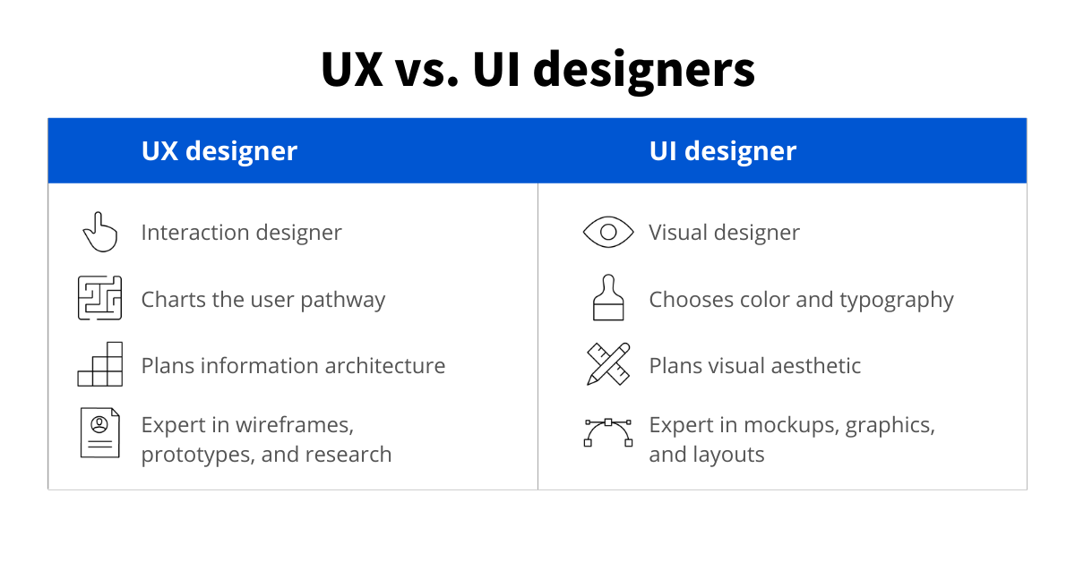

**How UI/UX of Products can be Improved**

**Consistent Design** :- Its concerned with making sure elements in a user interface are uniform. They'll look and behave the same way. This helps constantly prove a user's assumptions about the user interface right, creating a sense of control, familiarity, and reliability.

**Provide Engaging Content** :- Providing engaging content is key to a good website UX. Nowadays, visitors want more than a purchase, they want an experience. A great way to achieve this is by adopting an engaging content strategy to keep the User’s Fully engaged.

**Using Layout Strategically** :- Going with minimalist approach to layouts with a focus on user experience.

**Provide Information Concisely and Efficiently** :- By providing information in an elegant and structured way, to ensure that a user gets what they came for.

**Exclude Annoying Features** :- Website visitors are exposed to pop-ups, autoplay and information bombardment to the extent that makes them appreciate it when a site avoids the temptation to implement these annoying features.

**Simple & Clean Layout** :- Last but not Least, Making a Website clean and Simple helps user’s to easily figure out the contents & Elements of the Webpage and adapt to the web environment quickly.

**Custom Logo Designing**

As the Company’s name is “TechMauri”,I used the word Tech and Mauri(Bee) as a Keyword to search Google Images for grasping basic idea of Logo. This method is easy as we can grasp the idea of logo and instantly start sketching the shapes and design instead of randomly making different shapes and sizes, hoping to get an initial idea of Logo.

Here’s the WireFrame of Logo :

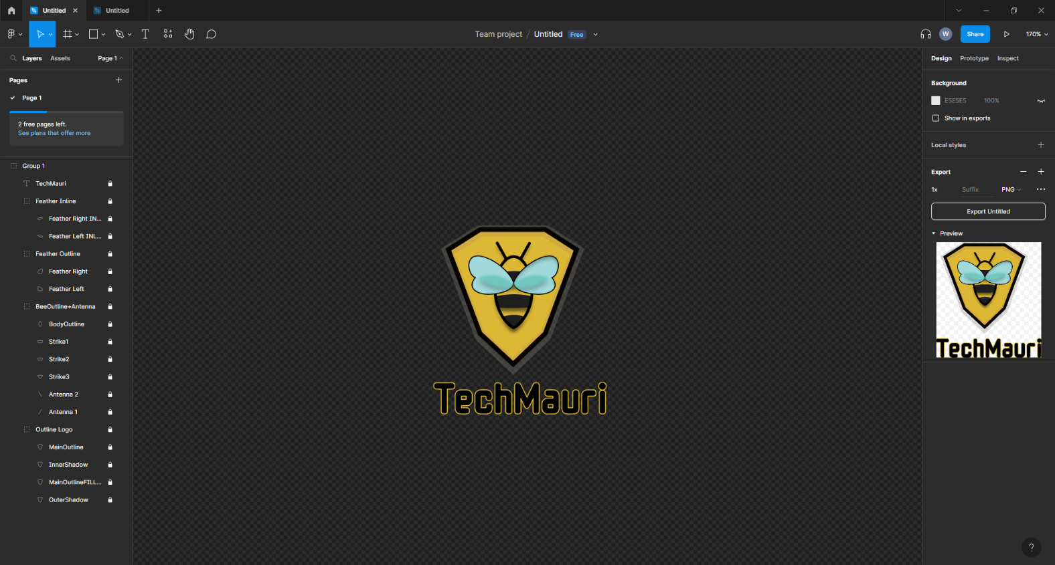

**Fig : Logo Wireframe**

**Login/SignIn Page WireFrame**

Before Starting to Directly program and create the actual webpage,its more reliable to create a simple blueprint of how the page should look like and what elements are to be used.

Here’s the WireFrame of Login/SignIn Page :

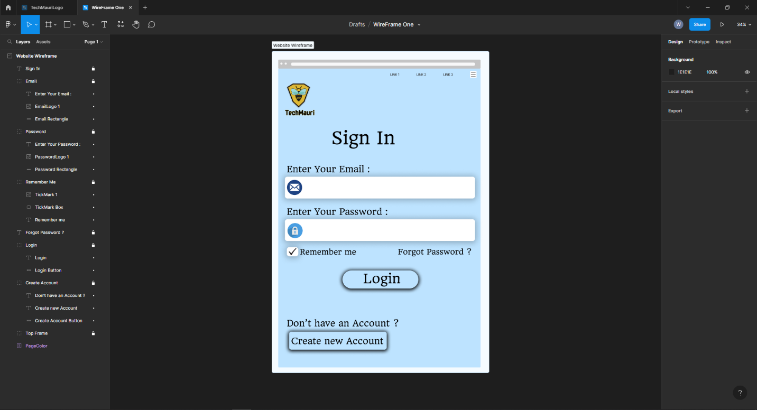

**Fig : WireFrame of Login/SignIn Page**

**Booking Page WireFrame**

WireFrame of Program Booking Page is Created by First Including all Necessary elements that has to be shown to user.

Here’s the WireFrame of Book Now Page :

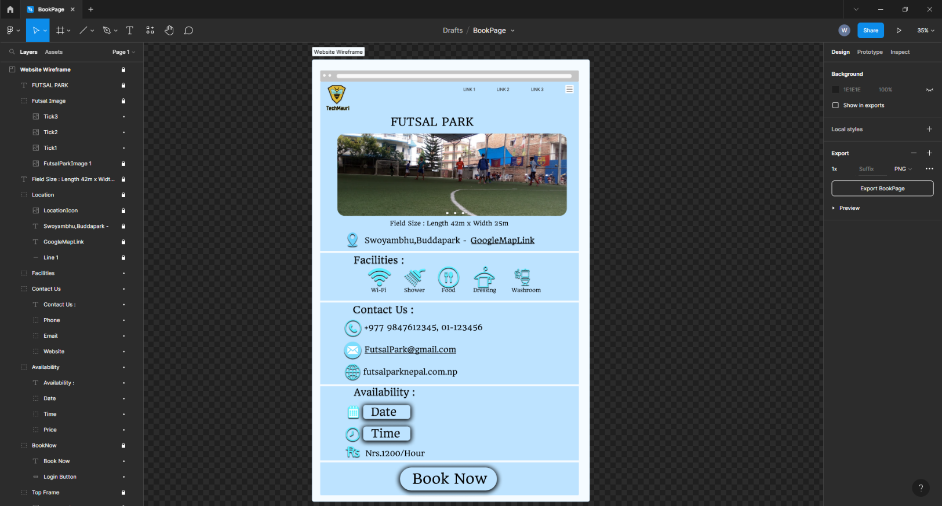

**Fig : WireFrame of BookNow Page**

“FIGMA” Software was used to create & Design Custom Logo and Multiple Webpage’s Wireframes.

From the Given Assignment, **SignIn** Page & **BookNow** Page were recreated by improving its UI/UX & Design.

**HTML & CSS** were used to Create the Webpages.

**SIGN IN WEBPAGE :**

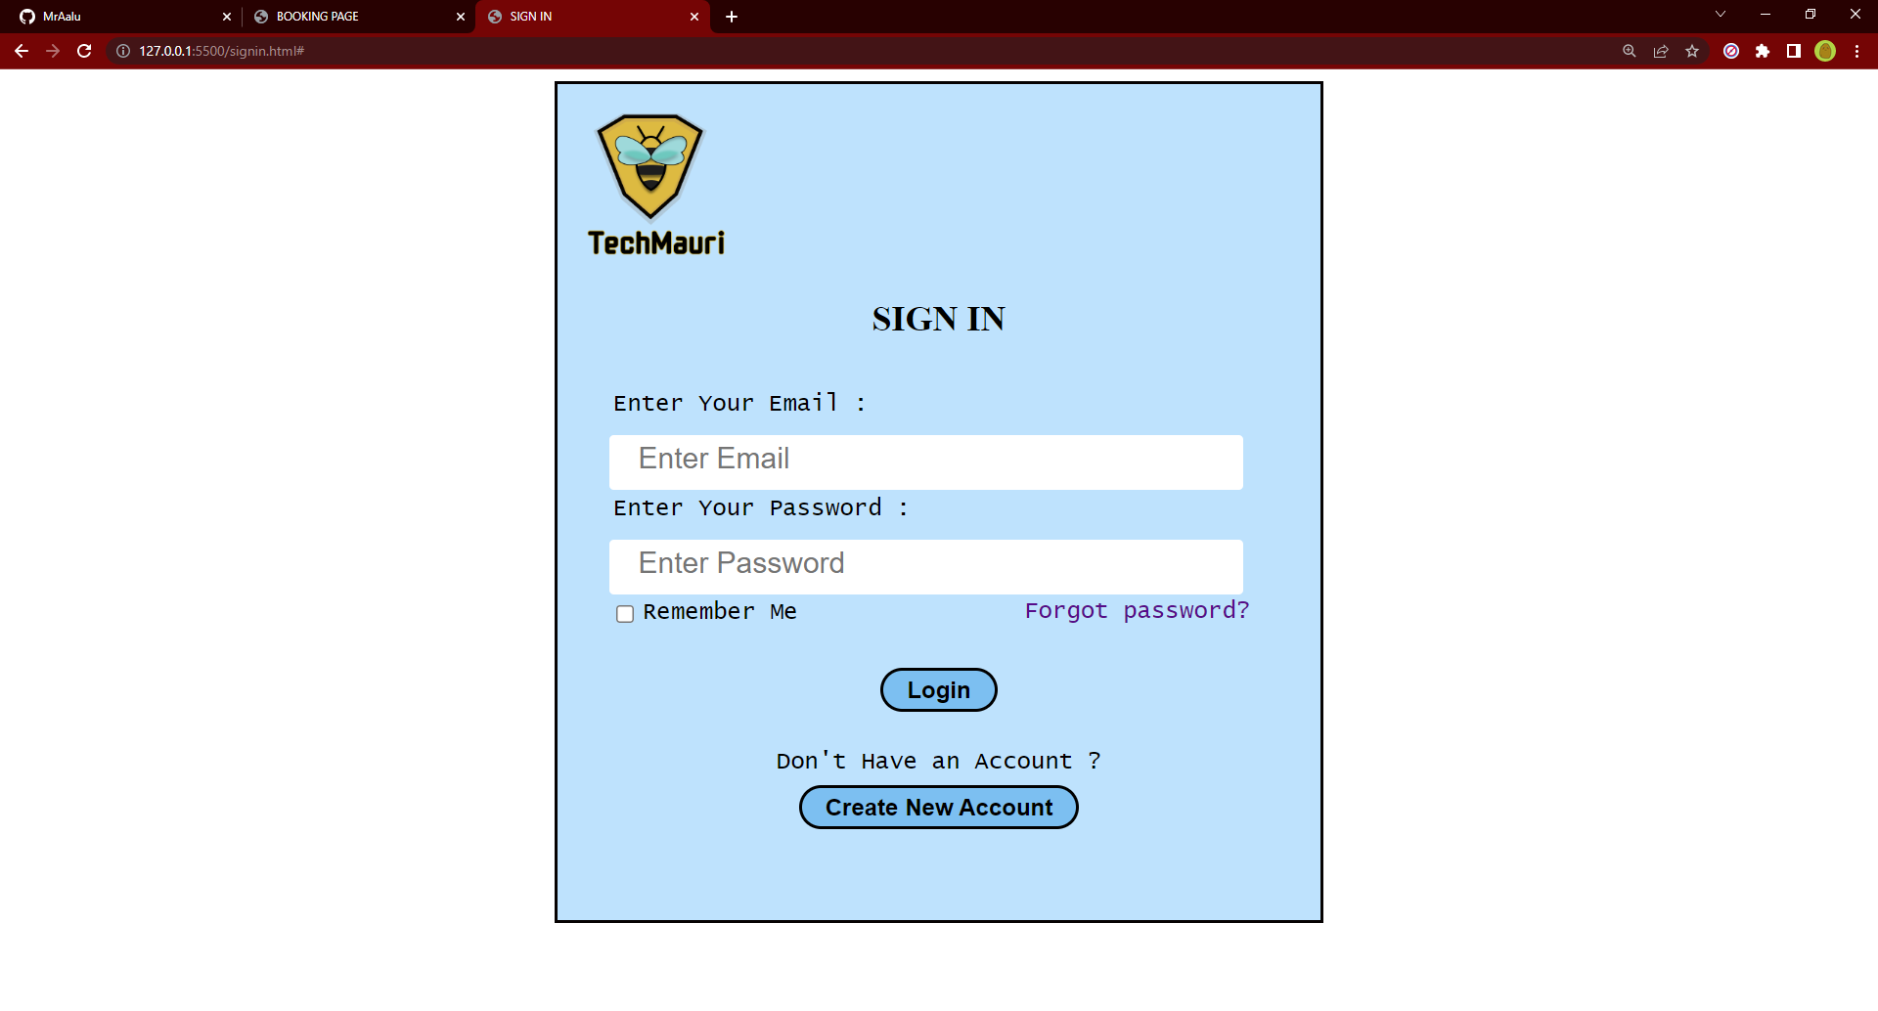

***FIG : Sigin Webpage***

SignIn page is Created using simple and clean Layout Followed by Color picked from the Logo.

Here, user can Enter Email in Email section and respectively for Password as well.

‘Remember me’ Option can be used to save user Login info for future login’s and can be Logged in through Login Button.

‘Forgot Password’ and ‘Create New Account’ option is given for users who lost their user login passwords so they can recover it and new users can create new account i.e. register respectively.

**BookNow Webpage :**

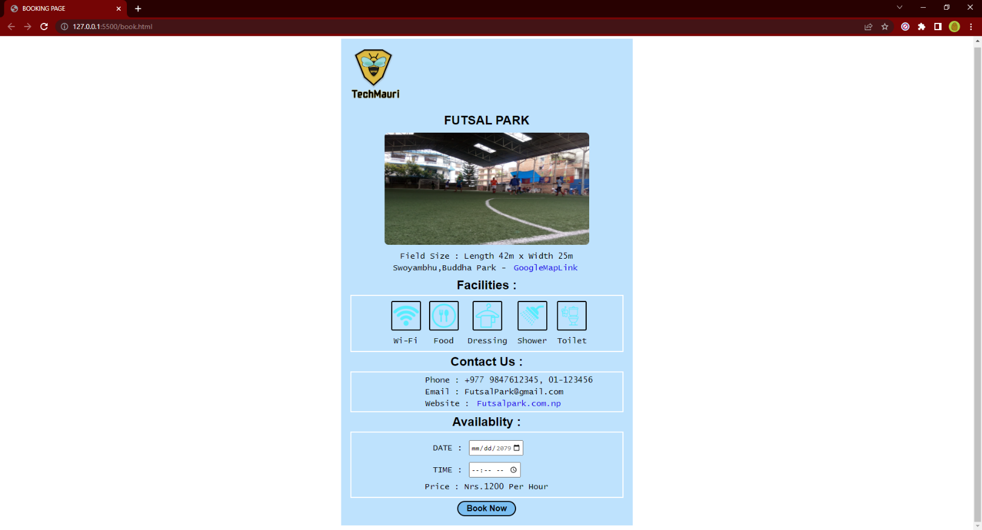

***FIG :BookNow Webpage***

FUTSAL PARK is used as Example for Booking Page.

Here, User can check Size of Futsal field and Its Location where user can also Click on GoogleMapLink to Open the the Map APP on his/her Device to find the best route to futsal park.

Next is, What sort of Facilities are Available in Futsal Park are Displayed to User’s. Also, Different sort of Contacts are Given for User to Enquiry and Communicate Directly.

In the Availablity Section,Date & Time is Given where we can Program it in such way that only available date and time are Unlocked to Choose/Pick and Already booked date and time can be Greyed Out then, below is the Price rate followed by Book now Button to Book the Futsal.

**Conclusion :**

**Figma** was Used to Design “TechMauri” LOGO and Webpages Wireframes.

**HTML & CSS** were used to Create these Webpages i.e. SignIn Page & BookNow Page.

Overall, Page Design and Color Themes is based on Logo and the Design is maded Consistent in all Pages.